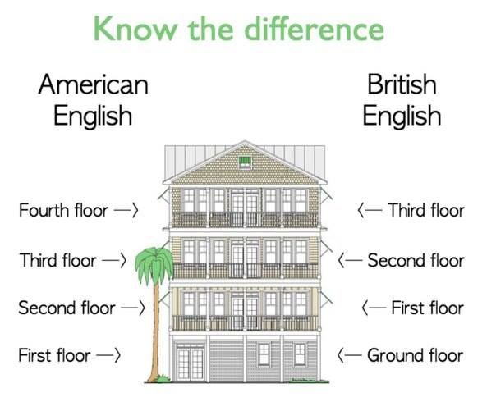

< -- Basement

**B**

**G**

**1**

**2**

Sales Assistant: Can I help you Sir/Madam?

Customer: Yes please, I am looking for a hat, are the hats on this floor?

Sales Assistant: Yes, we have some hats here on the ground floor. Are you looking for a hat for the summer or a hat for the winter?

Customer: I would like a hat for the summer, a sun hat.

Sales Assistant: This is a sun hat. Would you like to try it on?

Customer: Yes please, I will try it on.

Sales Assistant: Does it fit you?

Customer: No, it is too small. Do you have a bigger hat?

Sales Assistant: No, I am sorry that is the only one we have.

Customer: Thank you. I will look in another shop. Good bye.

Customer: Hello, please could you tell me where I can find the shirts?

Sales Assistant: Certainly Sir/Madam, are you looking for men’s shirts or ladies’ shirts?

Customer: I want a shirt for my child for school.

Sales Assistant: Children’s clothes are on the first floor. Is there anything else I can help you with Sir/Madam?

Customer: Thank you, that’s all I need.

Customer: Excuse me please, where is the café?

Sales Assistant: The café is on the second floor.

Customer: Where is the lift?

Sales Assistant: I am sorry, Sir/Madam, the lift is out of order.

Customer: That’s OK, I will walk up the stairs.